#Assignment A4-SQL#

Problem Statement: Write a PL/SQL block of code for the following requirements:-
Schema:
1. Borrower(Rollin, Name, DateofIssue, NameofBook, Status)
2. Fine(Roll_no,Date,Amt)
- Accept roll_no & name of book from user.
- Check the number of days (from date of issue), if days are between 15 to 30 then fine amount will be Rs 5per day.
- If no. of days>30, per day fine will be Rs 50 per day & for days less than 30, Rs. 5 per day.
- After submitting the book, status will change from I to R.
If condition of fine is true, then details will be stored into fine table.

Source Code:

-- Create the Borrowers table
CREATE TABLE Borrower_s (
BorrowerID NUMBER PRIMARY KEY,
BorrowerName VARCHAR2(100) NOT NULL,
IssueDate DATE NOT NULL,
BookTitle VARCHAR2(100) NOT NULL,
BookStatus VARCHAR2(1) CHECK (BookStatus IN ('I', 'R')) -- I for Issued, R for Returned
);

SELECT * FROM BORROWER_S;

-- Insert sample data into the borrower_s table
INSERT INTO borrower_s (BorrowerID, BorrowerName, IssueDate, BookTitle, BookStatus) VALUES (1, 'John Doe', TO_DATE('2023-09-05', 'YYYY-MM-DD'), 'The Alchemist', 'I');
INSERT INTO borrower_s (BorrowerID, BorrowerName, IssueDate, BookTitle, BookStatus) VALUES (2, 'Jane Smith', TO_DATE('2023-08-15', 'YYYY-MM-DD'), 'Sapiens', 'I');
INSERT INTO borrower_s (BorrowerID, BorrowerName, IssueDate, BookTitle, BookStatus) VALUES (3, 'Michael Brown', TO_DATE('2023-09-12', 'YYYY-MM-DD'), 'Becoming', 'I');
INSERT INTO borrower_s (BorrowerID, BorrowerName, IssueDate, BookTitle, BookStatus) VALUES (4, 'Emily Davis', TO_DATE('2023-07-20', 'YYYY-MM-DD'), 'Educated', 'I');
INSERT INTO borrower_s (BorrowerID, BorrowerName, IssueDate, BookTitle, BookStatus) VALUES (5, 'William Johnson', TO_DATE('2023-08-25', 'YYYY-MM-DD'), 'The Silent Patient', 'I');

-- Create the Fines table
CREATE TABLE Fine_s (
BorrowerID NUMBER,
FineDate DATE NOT NULL,
Amount NUMBER CHECK (Amount >= 0),
FOREIGN KEY (BorrowerID) REFERENCES Borrower_s(BorrowerID) -- Reference to Borrowers table
);

SELECT * FROM FINE_S;

DECLARE
v_borrower_id NUMBER;
v_book_title VARCHAR2(100);
v_issue_date DATE;
v_days NUMBER;
v_fine_amount NUMBER := 0;
v_book_status VARCHAR2(1); -- Added variable to hold BookStatus

-- -- Exception for no records found
no_record_found EXCEPTION;
-- PRAGMA EXCEPTION_INIT(no_record_found, -1403); -- ORA-01403: no data found

BEGIN
-- Accept input from user
v_borrower_id := &borrower_id; -- Assume input for borrower ID
v_book_title := '&book_title'; -- Assume input for book title

-- Fetch issue date and status from borrower_s table
SELECT IssueDate, BookStatus INTO v_issue_date, v_book_status
FROM borrower_s
WHERE BorrowerID = v_borrower_id AND BookTitle = v_book_title;

-- Calculate number of days since issue
v_days := TRUNC(SYSDATE - v_issue_date);

-- Calculate fine amount based on days
IF v_days BETWEEN 15 AND 30 THEN
v_fine_amount := (v_days * 5);
-- Commit the transaction
COMMIT;

EXCEPTION
WHEN no_record_found THEN
DBMS_OUTPUT.PUT_LINE('No record found for the given Borrower ID and Book Title.');
WHEN OTHERS THEN
DBMS_OUTPUT.PUT_LINE('An unexpected error occurred: ' || SQLERRM);
ROLLBACK;
END;
/ ELSIF v_days > 30 THEN
v_fine_amount := (30 * 5) + ((v_days - 30) * 50);
END IF;

-- Update the status of the book to 'Returned'
UPDATE borrower_s
SET BookStatus = 'R'
WHERE BorrowerID = v_borrower_id AND BookTitle = v_book_title;

-- If there is a fine, insert it into the fine_s table
IF v_fine_amount > 0 THEN
INSERT INTO fine_s (BorrowerID, FineDate, Amount)
VALUES (v_borrower_id, SYSDATE, v_fine_amount);
END IF;

-- Commit the transaction
COMMIT;

EXCEPTION
WHEN no_record_found THEN
DBMS_OUTPUT.PUT_LINE('No record found for the given Borrower ID and Book Title.');
WHEN OTHERS THEN
DBMS_OUTPUT.PUT_LINE('An unexpected error occurred: ' || SQLERRM);
ROLLBACK;
END;
/

Output:

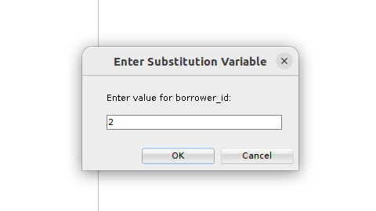
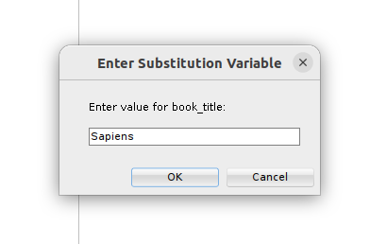

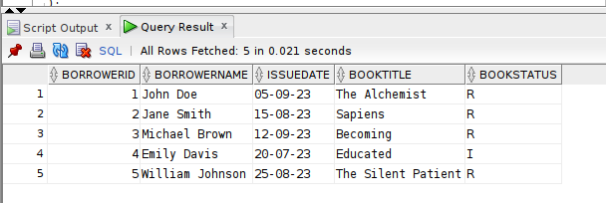
Borrower's Table
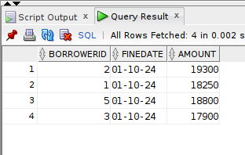
Fine Table

